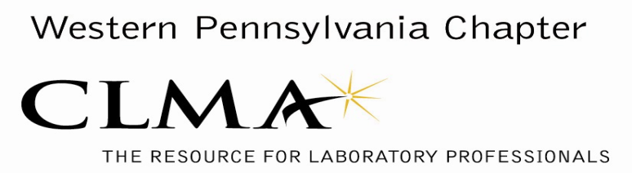

**CLMA/KEYPOCC Spring Networking Event**

## **Tuesday, May 7, 2019**

**VENDOR INFORMATION**

Dear Vendor Partner,

The Board of Directors of the Western Pennsylvania CLMA Chapter and KEYPOCC invite you to participate in our Spring Networking Event. This annual event is the premier gathering of local lab administrators, directors, supervisors, and decision makers. For this year’s event, we have extended the vendor exhibit time and will be initiating efforts to maximize interaction time between vendors and attendees. We will also be accepting a credit card again this year for the table fee.

Event Information:

Where: The Regional Learning Alliance

850 Cranberry Woods Drive

Cranberry Township, PA 16066

(724)741-1000

[www.therla.org](http://www.therla.org)

Date: Tuesday, May 7, 2019

Time: 8:30am – 3:00pm

Exhibit Set Up: 8:00am – 8:30am

Exhibit Time: 8:30am –3:00pm

Exhibit Tear Down: After 3:00pm

Cost: Payment by April 9, 2019:

$425.00 – includes one (1) exhibit table and one (1) lunch

Payment after April 9, 2019:

$475.00 – includes one (1) exhibit table and one (1) lunch

$75.00 – additional exhibit table

$40.00 – additional lunch

(The advance purchase of an exhibit table is required to attend the event.)

Vendor registration is **required by Tuesday, April 23, 2019 and full payment made by the day of the event**.

**\*\*\*\*Please complete and submit the attached form below to Christine McClure if paying by check or submit to Barb Day if paying by credit card (info below) to reserve your space at the event.\*\*\*\*\***

We sincerely thank you for your continued support of this annual event!

VENDOR REGISTRATION FORM

**CLMA/KEYPOCC**

**Spring Networking Event**

**Event Date - Tuesday, May 7, 2019**

**Registration Deadline: Tuesday, April 23, 2019**

Vendor/Company Name:

Representative/Contact Name:

Contact Phone:

Contact Email:

Attendee #1:

Attendee #2:

Attendee #3:

Attendee #4:

______ @ $425.00 One exhibit table + one lunch *(if paid prior to April 9, 2019)*

______ @ $475.00 One exhibit table + one lunch *(if paid after April 9, 2019)*

@ $75.00 Additional exhibit table(s)

@ $40.00 Additional lunch(es)

$ Total Amount Submitted (make check payable to **W. PA. CLMA**)

*Vendors sponsoring an event speaker will be provided one exhibit table and one lunch at no charge.*

**\*\*For Registration and Payment by Credit Card please submit to:**

**Barb Day at** [**bday@ExcelaHealth.org**](mailto:bday@ExcelaHealth.org)

**\*\*For Registration and Payment by Check, please submit to:**

Western Pennsylvania CLMA

Christine McClure

2247 Todd Road

Aliquippa, PA 15001

Phone: [412] 209-7391

Fax: [412] 209-7095

Email: cmcclure@itxm.org